COMP250 Assignment 1

1. List of all the entities

AS Qualifications

AS_Staff

AS_Ward

AS_WorkExperience

AS_Roster

AS_Room

AS_Requisition

AS_Patient

AS_NextofKin

AS_Appointment

AS_LabTest

AS_Doctor

AS_Medication

AS_Supplies

2. List each entity and all attributes associated with that entity.

**AS Qualifications**

Type

staffID

Date

institution

**AS_Staff**

staffID

firstName

lastName

address

phone

DOB

sex

SS#

position

currentSalary

salaryScale

Qualification

workExperience

**AS_Ward**

wardID

roomID

staffNumber

avgStay

wardType

chargeNurse

rosterID

**AS_WorkExperience**

Name

staffID

position

startDate

endDate

**AS_Roster**

rosterID

wardID

position

chargeNurse

staffID

**AS_Room**

roomID

patientID

wardID

**AS_Requisition**

requisitionID

productID

requestDate

deliveryDate

wardID

**AS_Patient**

patientID

firstName

lastNameaddress

phone

DOB

registrationID

sex

prescription

martialStatus

appointmentID

clinic#

**AS_NextofKin**

patientID

Name

address

phone

relationship

**AS_Appointment**

appointmentID

patientID

doctorID

Date

Time

doctorID

roomID

**AS_LabTest**

labTestID

patientID

results

**AS_Doctor**

clinic#

Name

address

phone

wardID

**AS_Medication**

Prescription

drugID

Name

unitsPerDay

Method

timeLength

productID

**AS_Supplies**

productID

Supplier

Type

quantity

3. Draw the binary relationship between the entities and the two “for-each” sentences that will help you specify the cardinality and optionality.

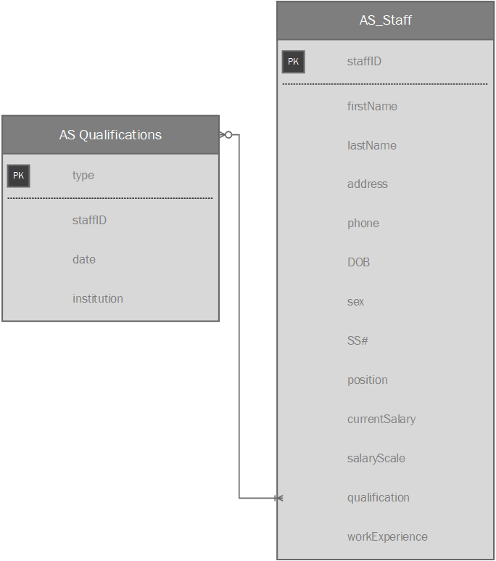

1. Determine the number of times AS_Qualifications participates in the relationship.

Can a AS_Qualification be earned by more than one staff? No

1. Determine if every instance of AS_Qualifications participates in the relationship.

Can there be a qualification in the system that has not been earned? No

1. Determine the number of times AS_Staff participates in the relationship.

Can staff earn more than one qualification? Yes

1. Determine if every instance of AS_Staff participates in the relationship.

Can there be a staff in the system that has not earned a qualification? Yes

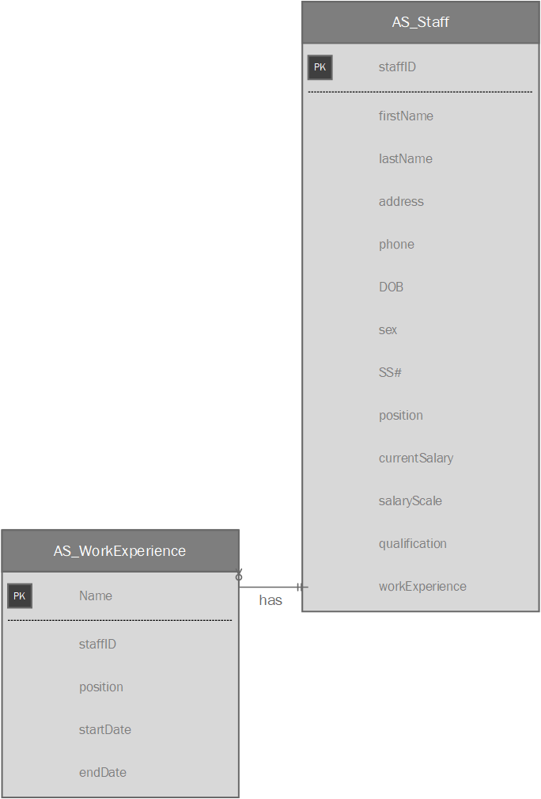

Determine the number of times AS_WorkExperience participates in the relationship.

Can a AS_WorkExperience be had by more than one staff? No

Determine if every instance of AS_WorkExperience participates in the relationship.

Can there be a work experience in the system that has not been earned? No

Determine the number of times AS_Staff participates in the relationship.

Can staff earn more than one work experience? Yes

Determine if every instance of AS_Staff participates in the relationship.

Can there be a staff in the system that has not earned a work experience? Yes

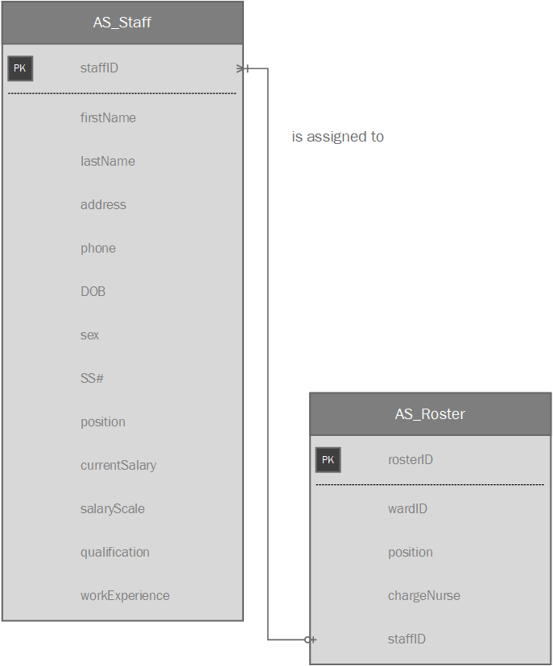

Determine the number of times AS_Roster participates in the relationship.

Can a roster have more than one staff assigned to it? Yes

Determine if every instance of AS_Roster participates in the relationship.

Can there be a roster without employees assigned? Yes

Determine the number of times AS_Staff participates in the relationship.

Can staff be assigned to more than one roster? No

Determine if every instance of AS_Staff participates in the relationship.

Can there be a staff in the system that is not assigned to a roster? Yes

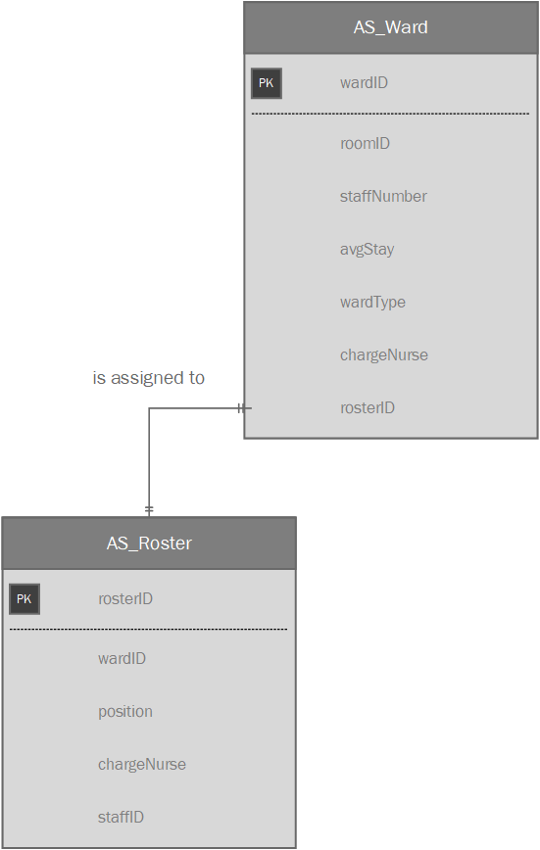

Determine the number of times AS_Roster participates in the relationship.

Can a roster be assigned to more than one ward? No

Determine if every instance of AS_Roster participates in the relationship.

Can there be a roster not assigned to a ward? No

Determine the number of times AS_Ward participates in the relationship.

Can ward be assigned to more than one roster? No

Determine if every instance of AS_Ward participates in the relationship.

Can there be a ward in the system that is not assigned a roster? Yes

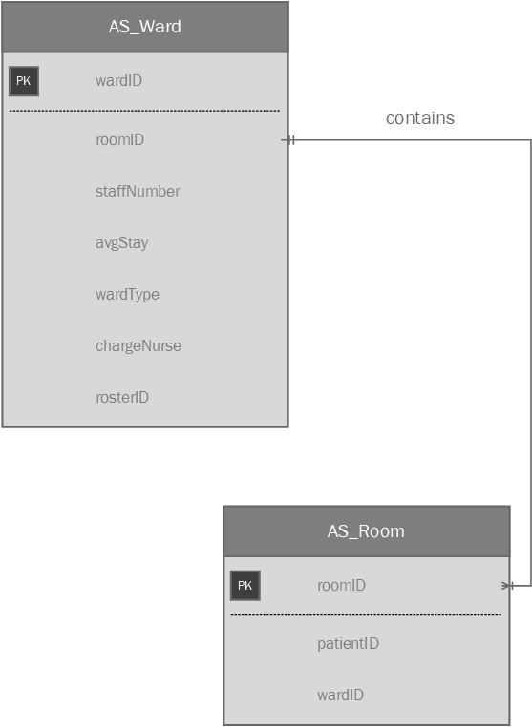

Determine the number of times AS_Ward participates in the relationship.

Can a ward contain more than one room? Yes

Determine if every instance of AS_Ward participates in the relationship.

Can there be a ward that does not contain rooms? No

Determine the number of times AS_Room participates in the relationship.

Can a room be contained by more than one ward? No

Determine if every instance of AS_Room participates in the relationship.

Can there be a room in the system that is not contained by a ward? No

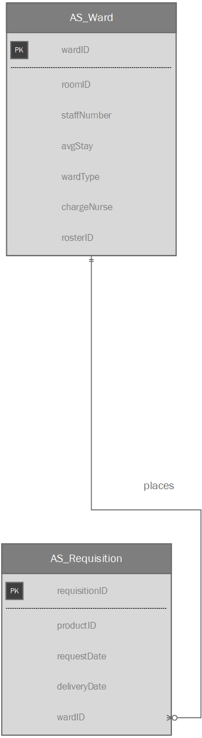

Determine the number of times AS_Ward participates in the relationship.

Can a ward place more than one requisition? Yes

Determine if every instance of AS_Ward participates in the relationship.

Can there be a ward that does not place requisitions? Yes

Determine the number of times AS_Requisition participates in the relationship.

Can a requisition be placed by more than one ward? No

Determine if every instance of AS_Requisition participates in the relationship.

Can there be a requisition in the system that is not placed by a ward? No

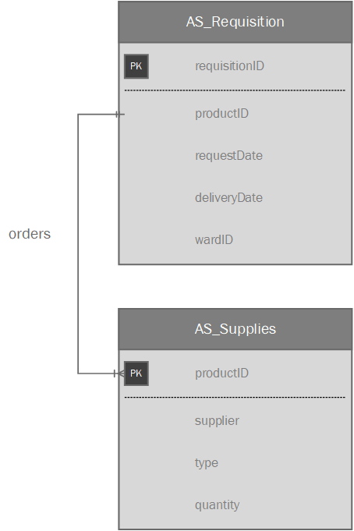

Determine the number of times AS_Requisition participates in the relationship.

Can a requisition order more than one supply? Yes

Determine if every instance of AS_Requisition participates in the relationship.

Can there be a requisition that does not contain supplies? No

Determine the number of times AS_Supplies participates in the relationship.

Can supplies be on more than one requisition? Yes

Determine if every instance of AS_Supplies participates in the relationship.

Can there be a supply in the system that is not ordered by a requisition? Yes

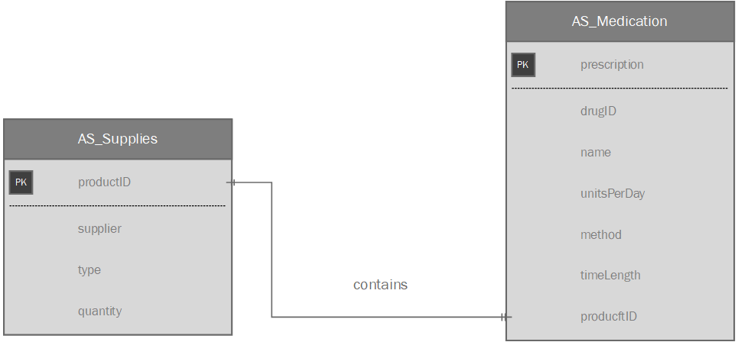

Determine the number of times AS_Medication participates in the relationship.

Can medication be contained by more than one supplies? Yes

Determine if every instance of AS_Medication participates in the relationship.

Can there be a medication not contained by supplies? Yes

Determine the number of times AS_Supplies participates in the relationship.

Can supplies contain more than one medication? Yes

Determine if every instance of AS_Supplies participates in the relationship.

Can there be supplies that do not contain medication? Yes

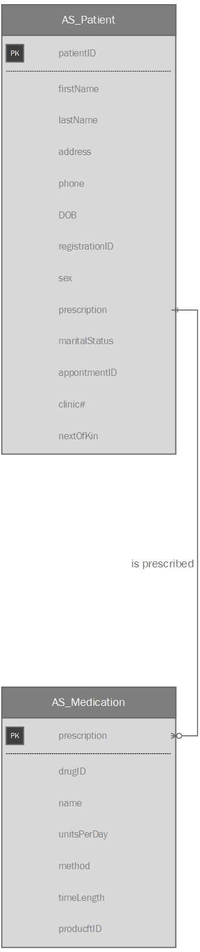

Determine the number of times AS_Medication participates in the relationship.

Can medication be prescribed to more than one patient? Yes

Determine if every instance of AS_Medication participates in the relationship.

Can there be a medication not prescribed to patients? Yes

Determine the number of times AS_Patient participates in the relationship.

Can a patient be prescribed more than one medication? Yes

Determine if every instance of AS_Patient participates in the relationship.

Can there be a patient not prescribed medication? Yes

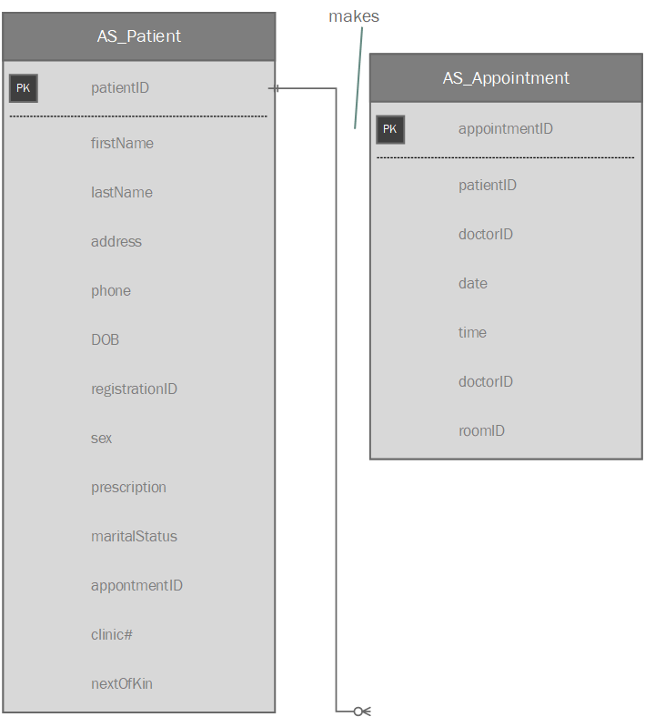

Determine the number of times AS_Appointment participates in the relationship.

Can an appointment be made by more than one patient? No

Determine if every instance of AS_Appointment participates in the relationship.

Can there be an appointment not made by a patient? No

Determine the number of times AS_Patient participates in the relationship.

Can a patient make more than one appointment? Yes

Determine if every instance of AS_Patient participates in the relationship.

Can there be a patient that does not make an appointment? Yes

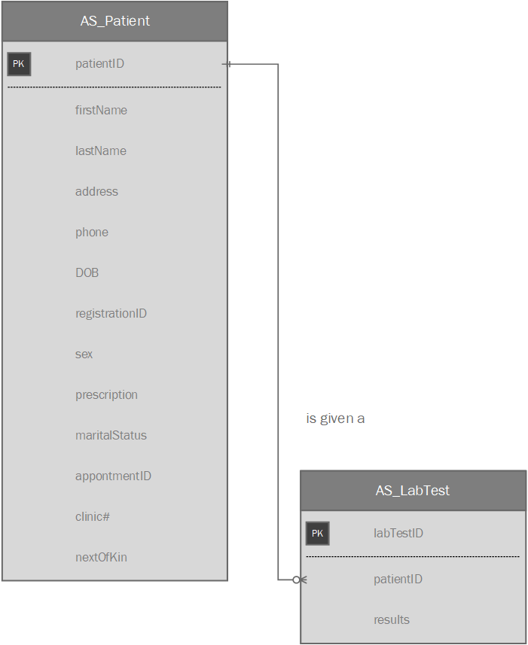

Determine the number of times AS_LabTest participates in the relationship.

Can a lab test be given to more than one patient? No

Determine if every instance of AS_LabTest participates in the relationship.

Can there exist a lab test that has not been given to a patient? No

Determine the number of times AS_Patient participates in the relationship.

Can a patient be given more than one lab test? Yes

Determine if every instance of AS_Patient participates in the relationship.

Can there be a patient that is not given a lab test? Yes

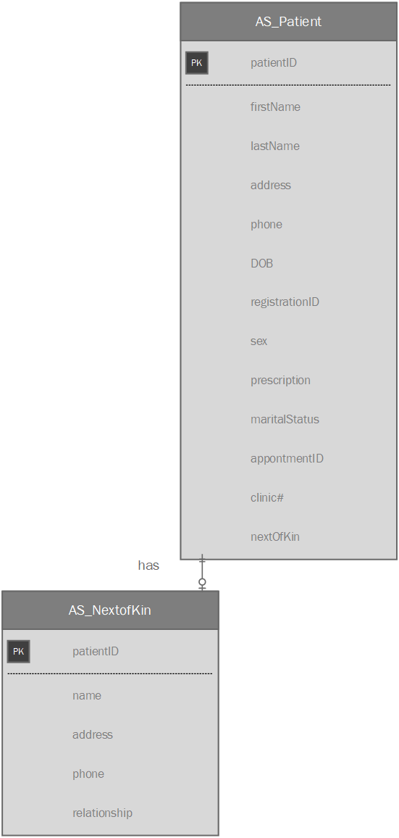

Determine the number of times AS_NextOfKin participates in the relationship.

Can a next of kin be had by more than one patient? No

Determine if every instance of AS_NextOfKin participates in the relationship.

Can there exist a next of kin not had by a patient? No

Determine the number of times AS_Patient participates in the relationship.

Can a patient have more than one next of kin? No

Determine if every instance of AS_Patient participates in the relationship.

Can there be a patient that does not have a next of kin? Yes

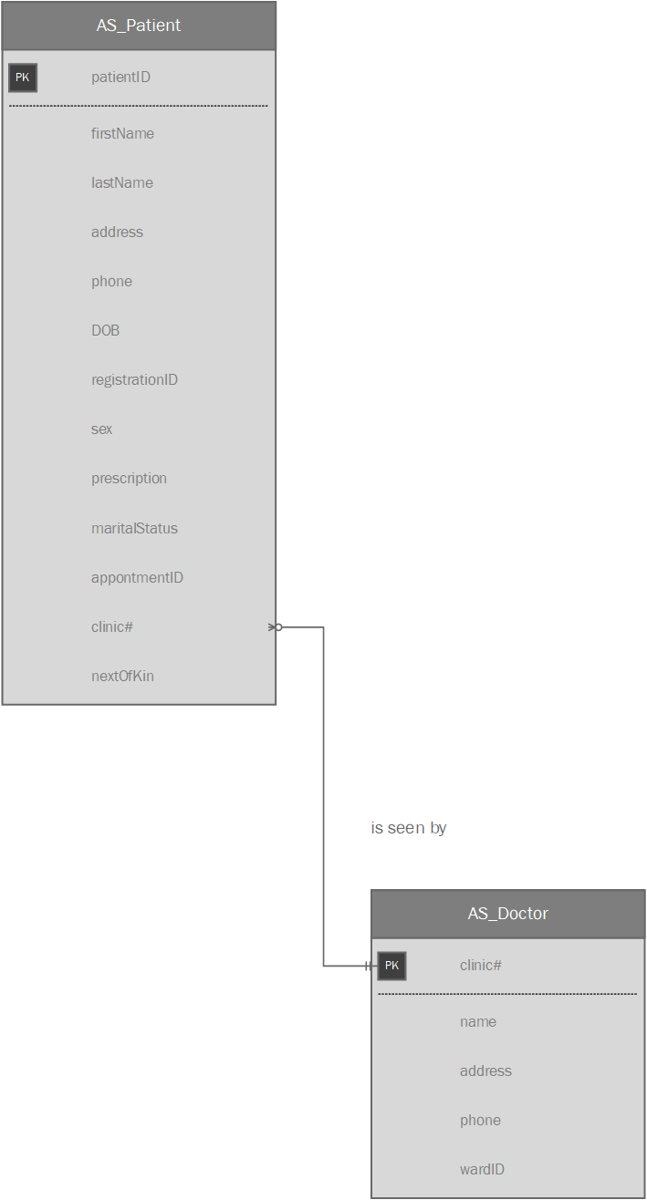

Determine the number of times AS_Doctor participates in the relationship.

Can a doctor be seen by more than one patient? Yes

Determine if every instance of AS_Doctor participates in the relationship.

Can there exist a doctor not seen by a patient? Yes

Determine the number of times AS_Patient participates in the relationship.

Can a patient be seen by more than one doctor? Yes

Determine if every instance of AS_Patient participates in the relationship.

Can there be a patient that is not seen by a doctor? Yes

4. E-R diagram printed on one page. Use landscape orientation

